**Laboratory 1: Device characterization**

**Aim**

* To get acquainted with the MOS device.
* Measure and plot your measurements of ID vs VGS for MN1 for different values of VGS1
* Estimate the threshold voltage, VT of the devices.
* Measure and plot ID vs VDS for the device MN1, for different values of VGS.
* Plot ID flowing out of the drain vs VSG and VSD.
* Apply different voltages at the gate and plot the voltages observed at the drain.
* Find the frequency at which the output is no longer resembles a square wave, but changes into a sine wave.

**Apparatus required**

* Resistors (470Ω, 1000Ω, 4700Ω, 10000Ω, etc)
* DC Power Supply
* IC CD4007
* Probes
* Breadboard
* Wires
* Oscilloscope
* Function Generator

**Theory and Procedure and Results and Calculations**

1. **NMOS 1 -** Measure ID vs VGS for MN1 for different values of VGS

* connect drain and gate together,i.e., Vds =Vgs
* Use different resistors (R1) to control the voltage Vgs. Pick these resistors as the experiment progresses, such that you obtain a variety of gate voltages.
* Use the schematic shown below.
* 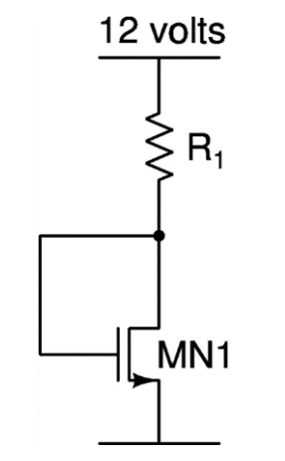
* Measure Vds
* Vds = Vd – Vs = Vd , (Vs = 0)
* Vds = vgs

$Id=\frac{(Vdd-Vds)}{R1}$

1. NMOS 2 - Measure ID vs VDS for the device MN1 only, for different values of VGS

* use different values of the resistors R1 and R2
* For R2, use resistors 470, 1k, 3k, 4.7k, 10k. For R1 use resistors as before.
* Use the schematic as shown below.
* 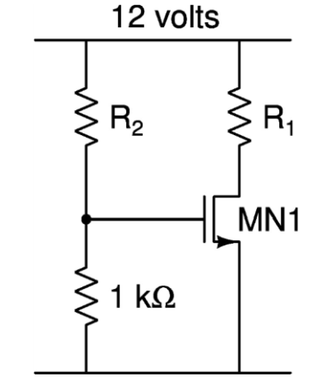
* Measure Vds
* Vds = Vd – Vs = Vd , (Vs = 0)

$Id=\frac{(Vdd-Vds)}{R1}$

1. PMOS 1 - Measure ID vs Vsg for MP1 for different values of VGS.

* connect drain and gate together,i.e., Vds =Vgs
* Use different resistors (R1) to control the voltage Vgs. Pick these resistors as the experiment progresses, such that you obtain a variety of gate voltages.
* Use the schematic shown below.
* .
$Id= \frac{Vd}{R1}$

* Vsd = Vs – Vd = Vdd – idrd
* Vsd = vsg

1. PMOS 2 - Measure ID vs Vsd for the device MP1 only, for different values of Vsg

* use different values of the resistors R1 and R2
* For R2, use resistors 470, 1k, 3k, 4.7k, 10k. For R1 use resistors as before.
* Use the schematic as shown below.
* .

**Reading in tabular form and Observations**

**Graphs**

**Snapshots**

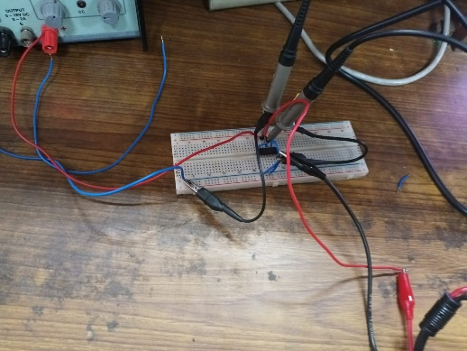

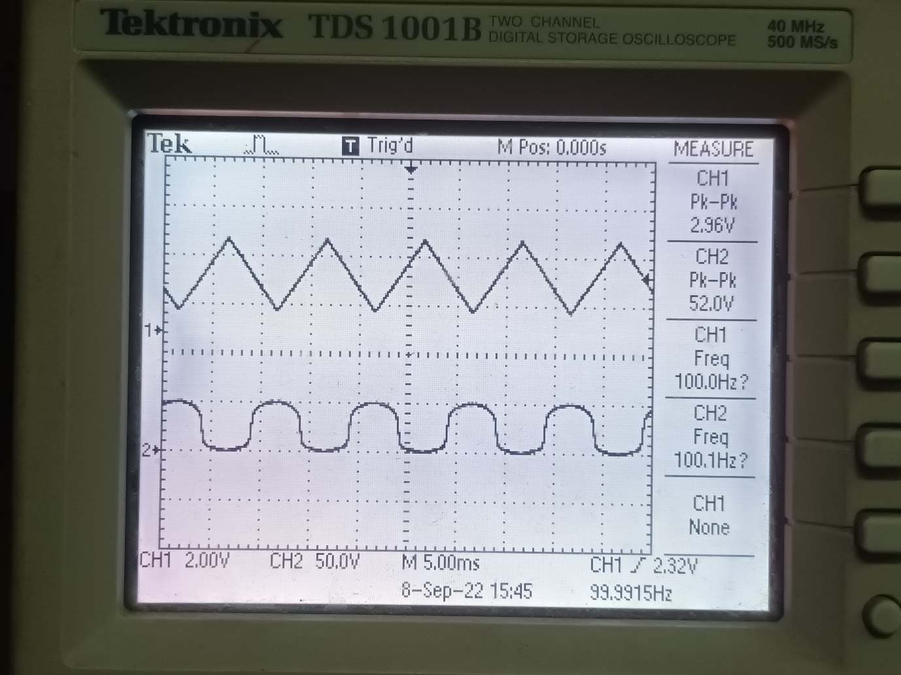

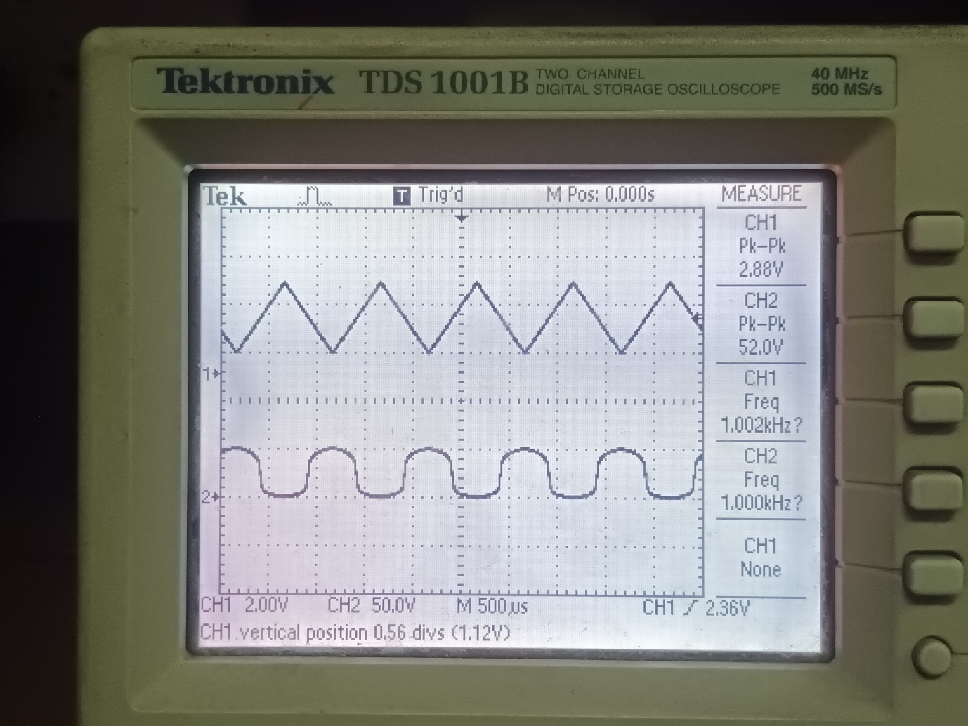

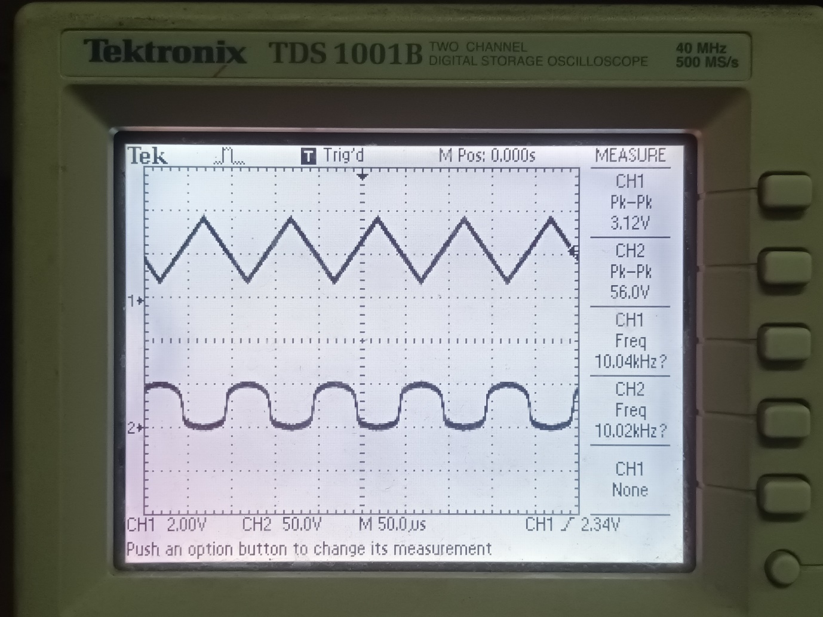

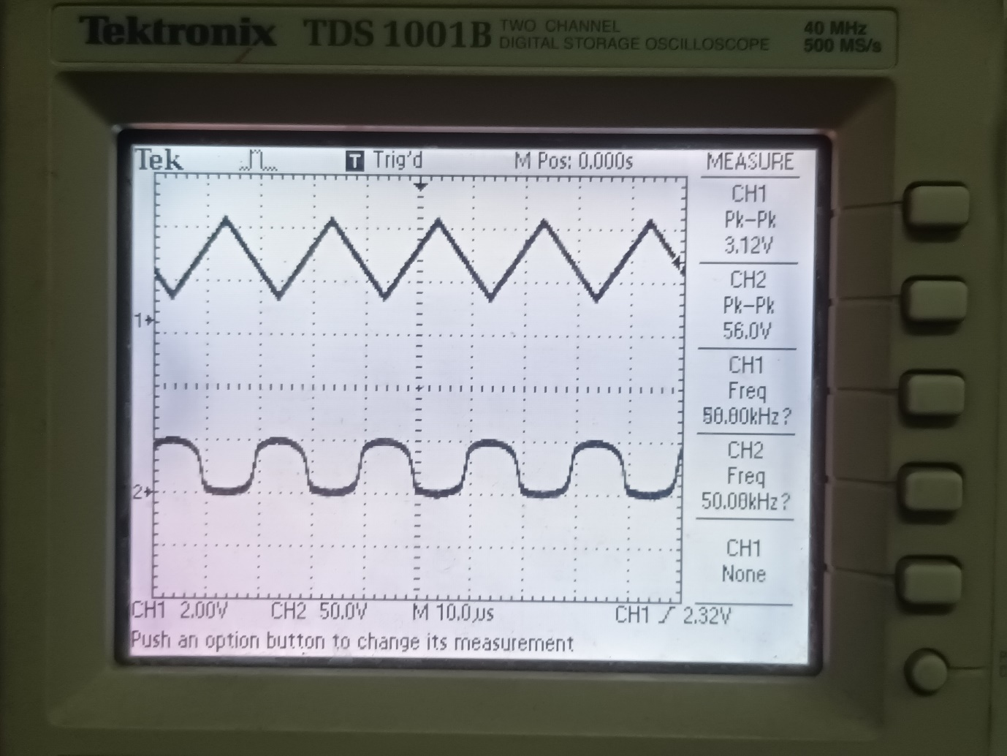

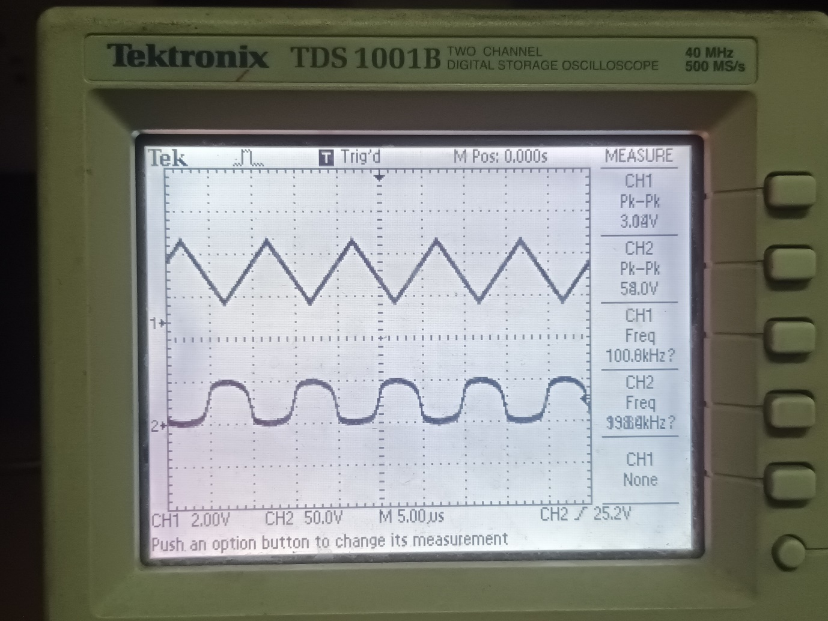

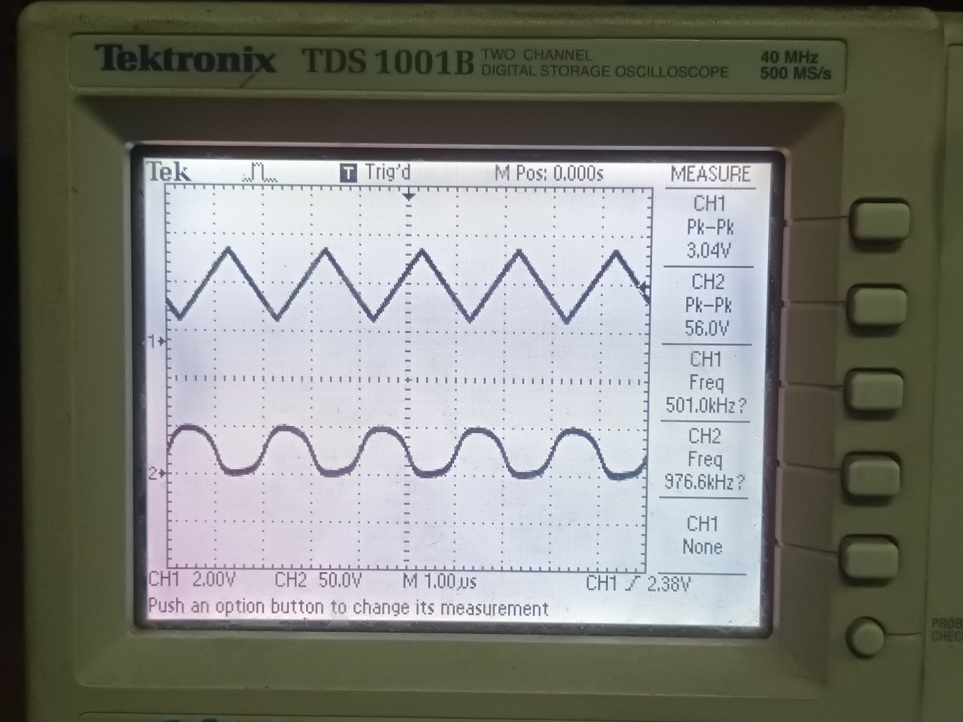

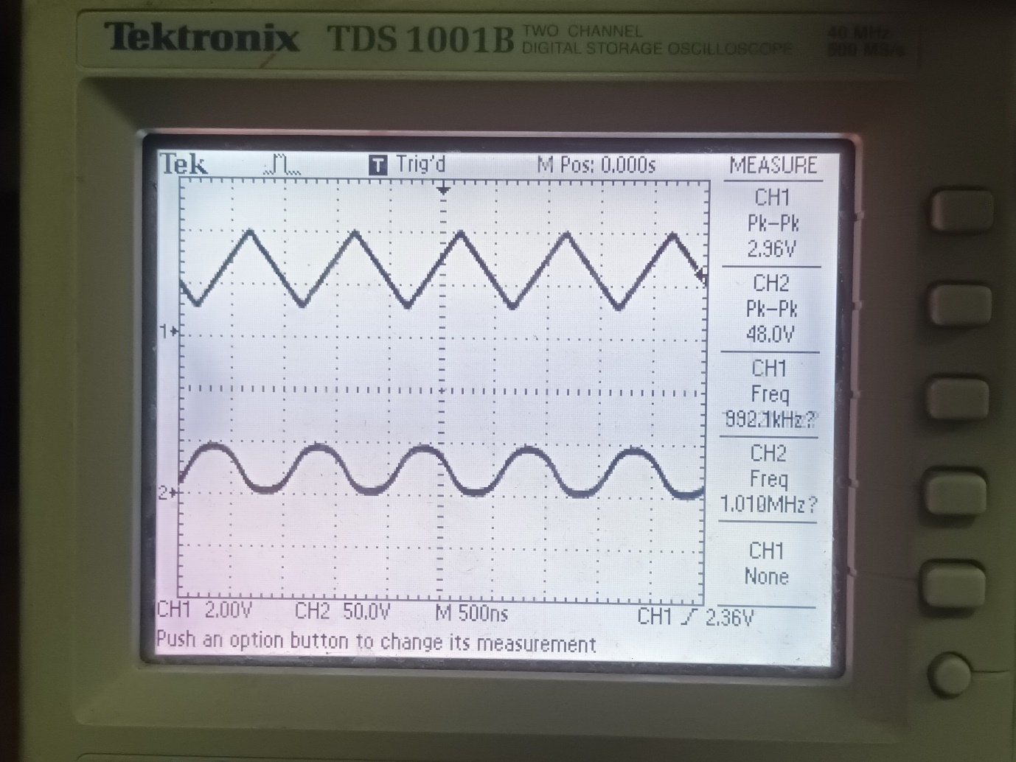

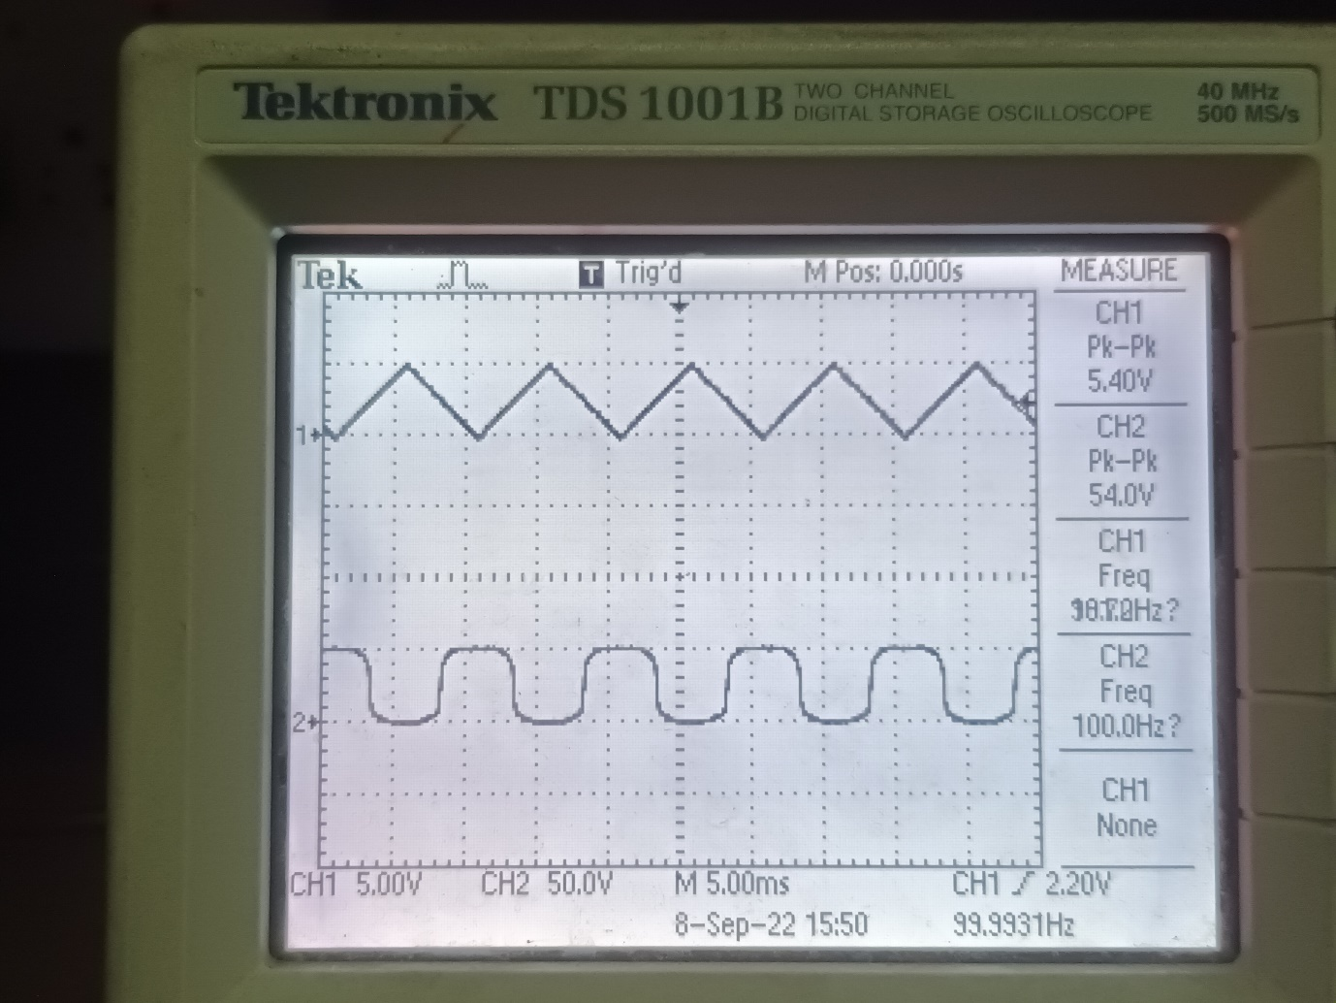

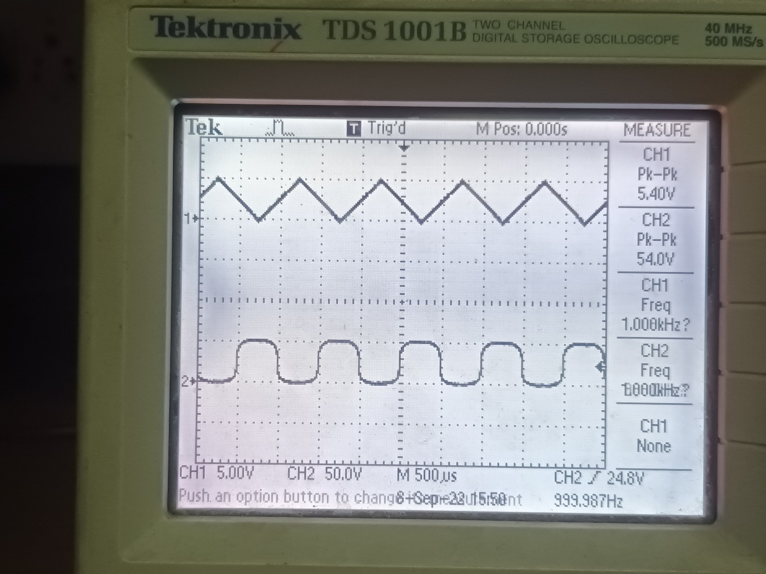

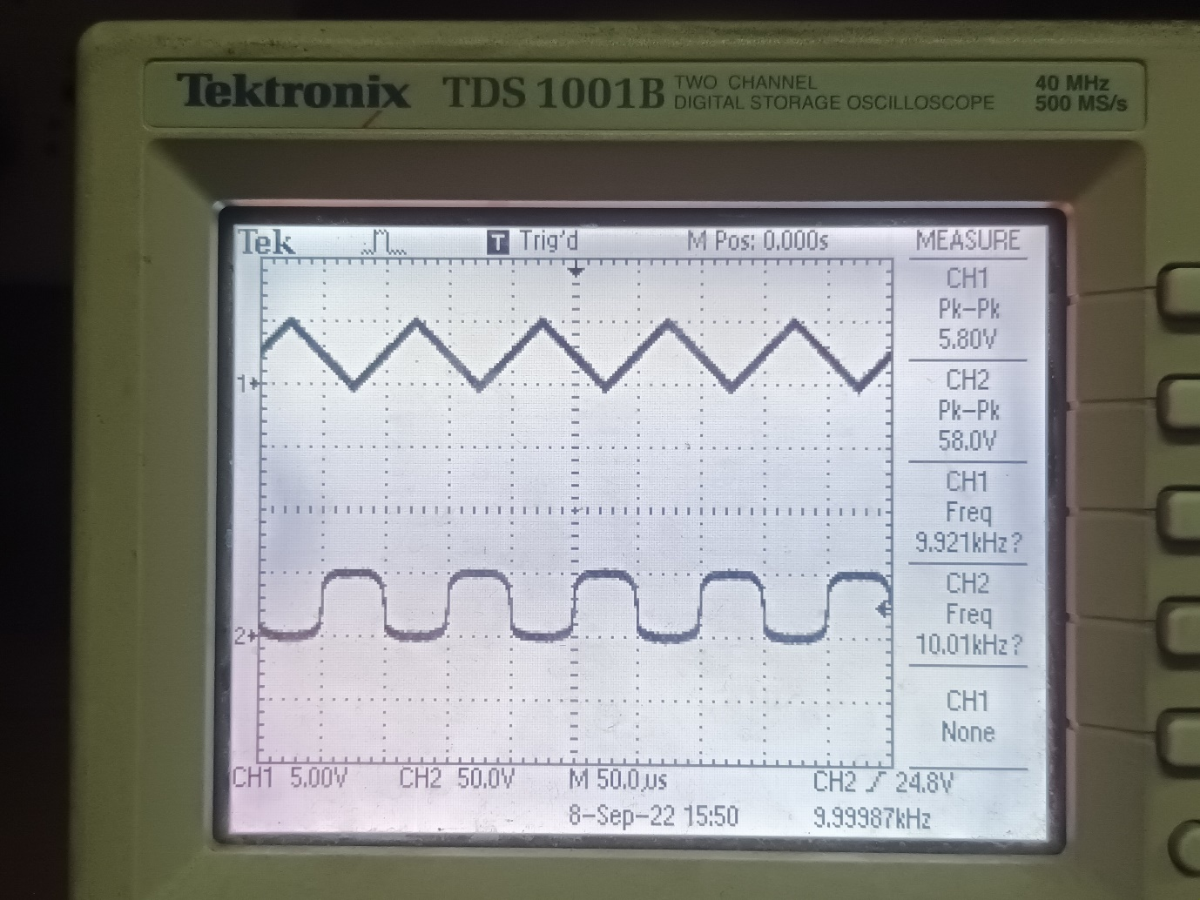

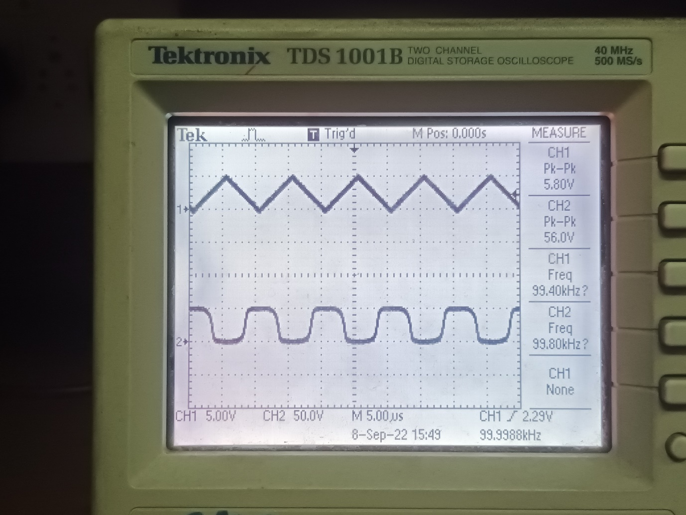

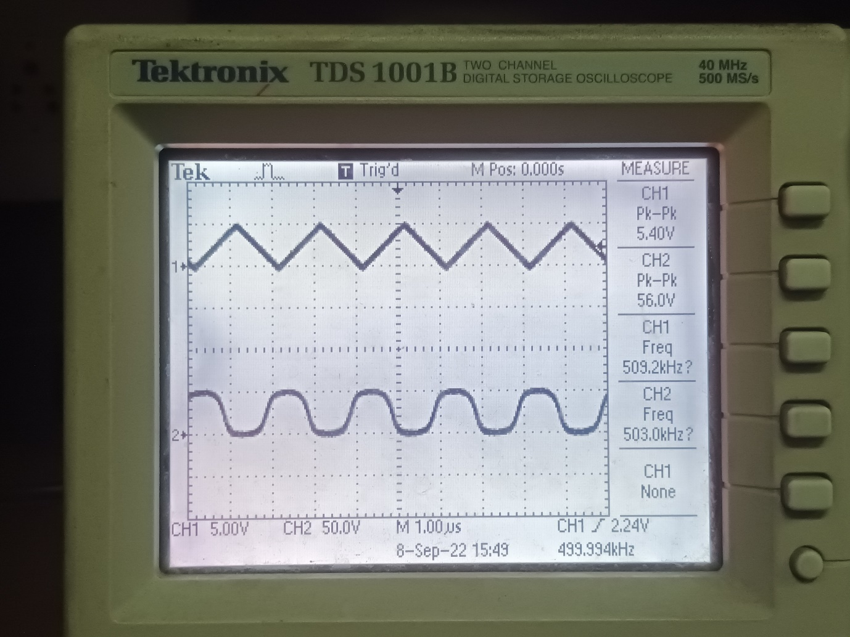

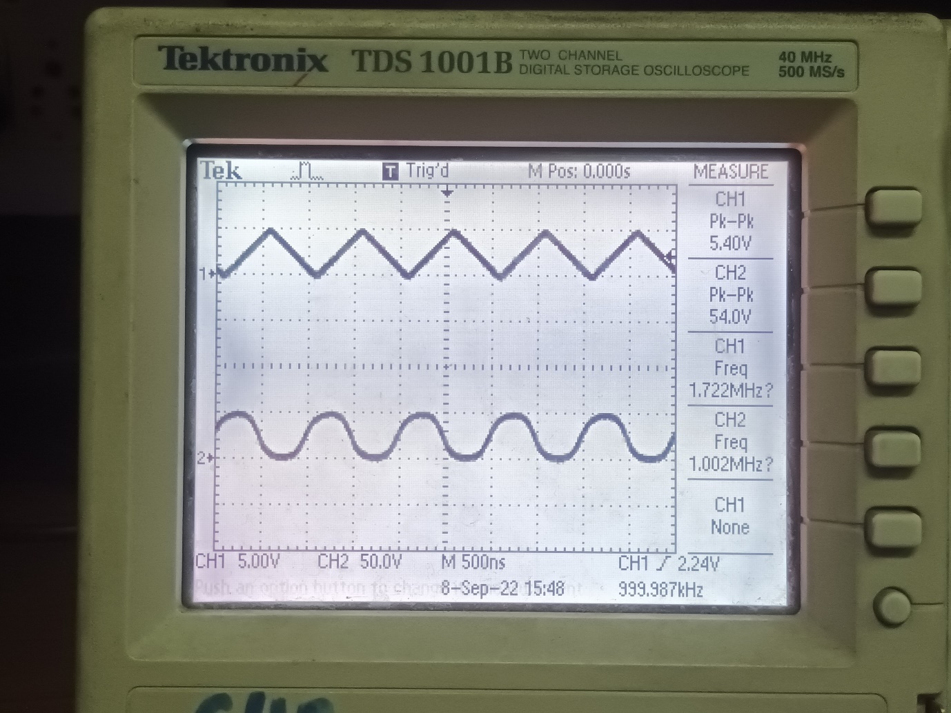

**Case 3 – Vpk-pk = 7V**

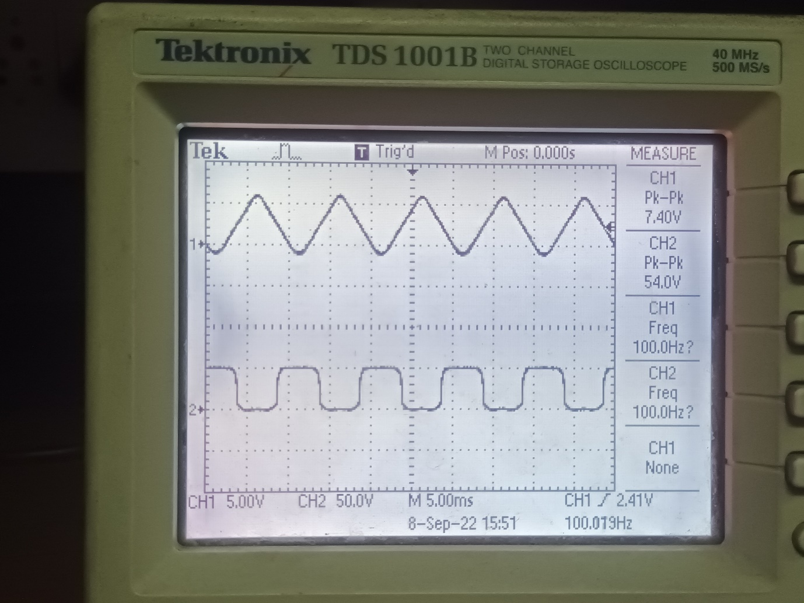

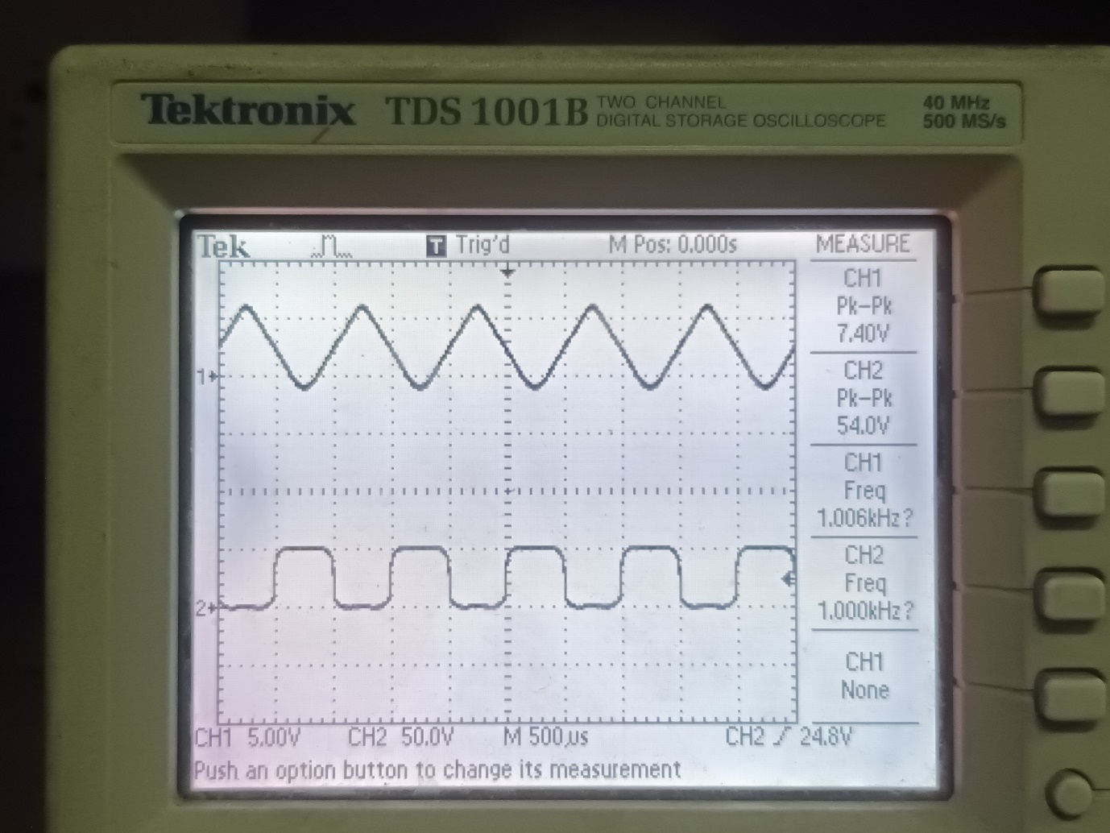

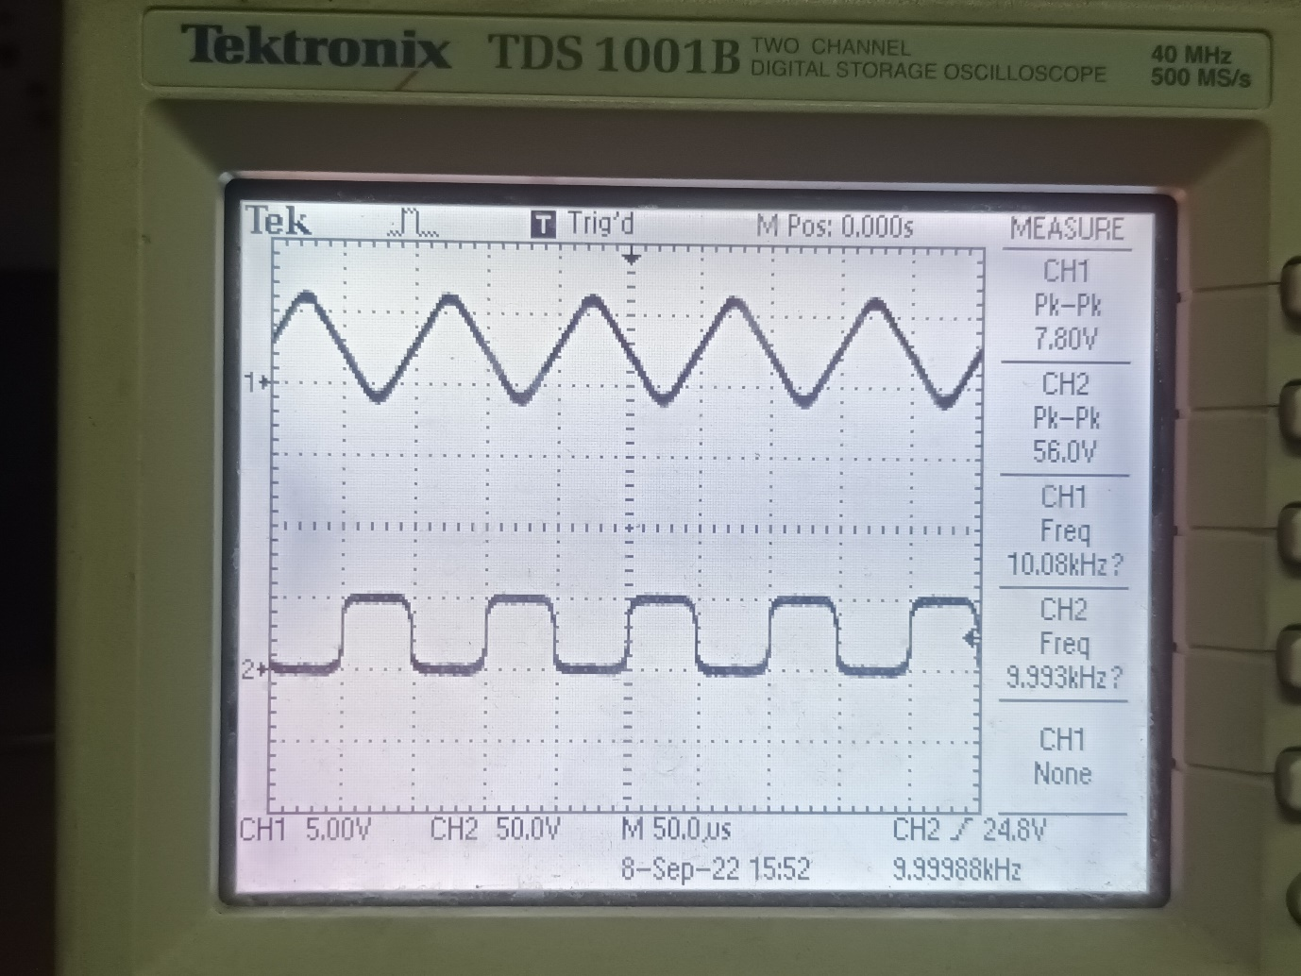

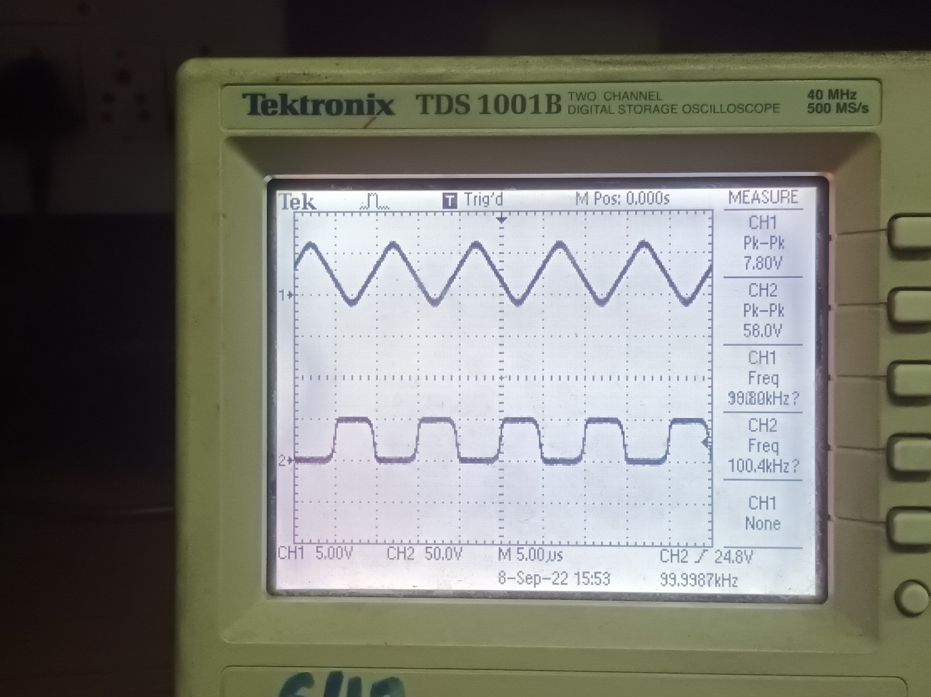

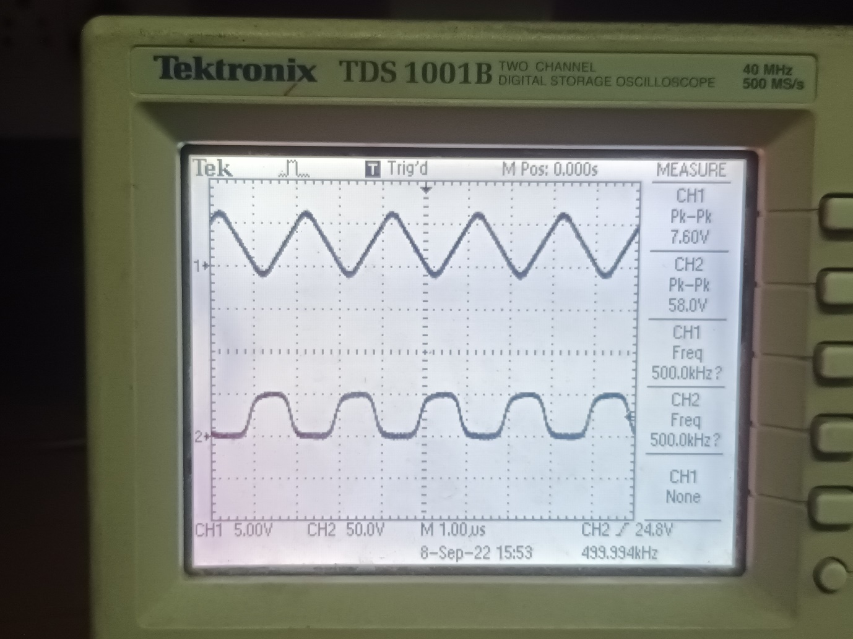

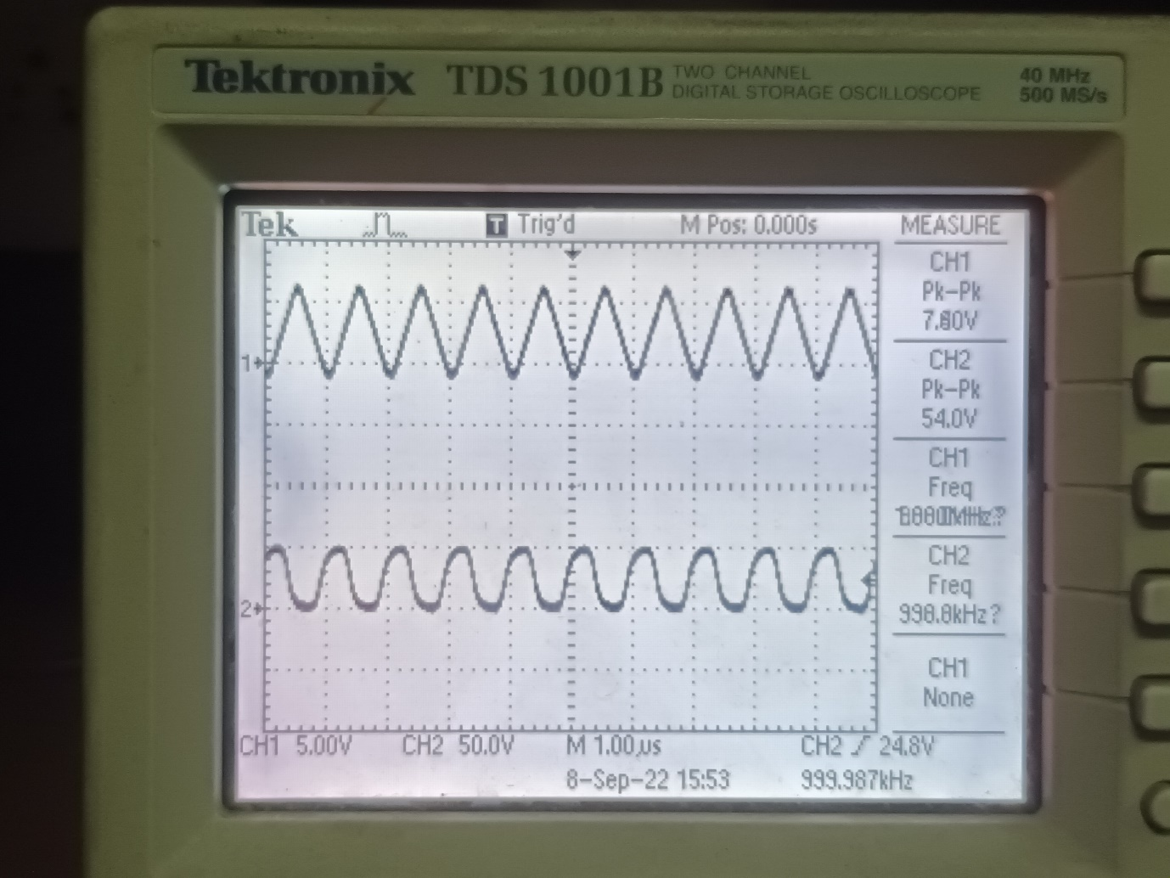

**Conclusion**

**The**